**NATIONAL UNIVERSITY OF COMPUTER AND EMERGING SCIENCES**

**(MAIN CAMPUS KARACHI)**

Department of Computer Science

**FALL 2020**

DATABASE

**PROJECT REPORT**

**EVENT HUB**

**Contents**

Introduction: 1

Project Description: 1

Technologies: 2

Code Explanation: 2

DATABASE: 12

ERD(Entity Relationship Diagram): 14

Normalization 15

Project Walkthrough:……………………………………………………………………………………………….15

Future Work: 16

Conclusion: 16

**Team Member:...………………………………………………………………………………………..18**

# **Introduction**:

We built a web application that put all events happening in Pakistan in one website where a user can login to see all events, add events, search for an event

# Project Description:

The project will consist 3 panels.

1. Browsing Users
2. Users
3. Admin
4. Add events
5. Add profession
6. Show event
7. Hire professional
8. Approve event

A **Browsing user** is be able to **browse** through events happening near him. He can search the events

* city wise (Karachi ,Lahore, Peshawar, Quetta)
* Category wise (Qawali, Concert, Carnival)

A **Browsing user** can **add an event** of his own with specific details for other users to browse but he would need to **login** if his account already exists or **register** if he is new which then brings us to **user panel.** An event will only be shown once it is **approved** by admin, which brings us to **Admin panel**. An admin can delete an event, delete a user, and check user details.

# **Technologies**:

* Html
* CSS
* PHP
* MySQL

# Code Explanation:

* HEADER:

This is HEADER display and code and HEADER is shown in top of every page.



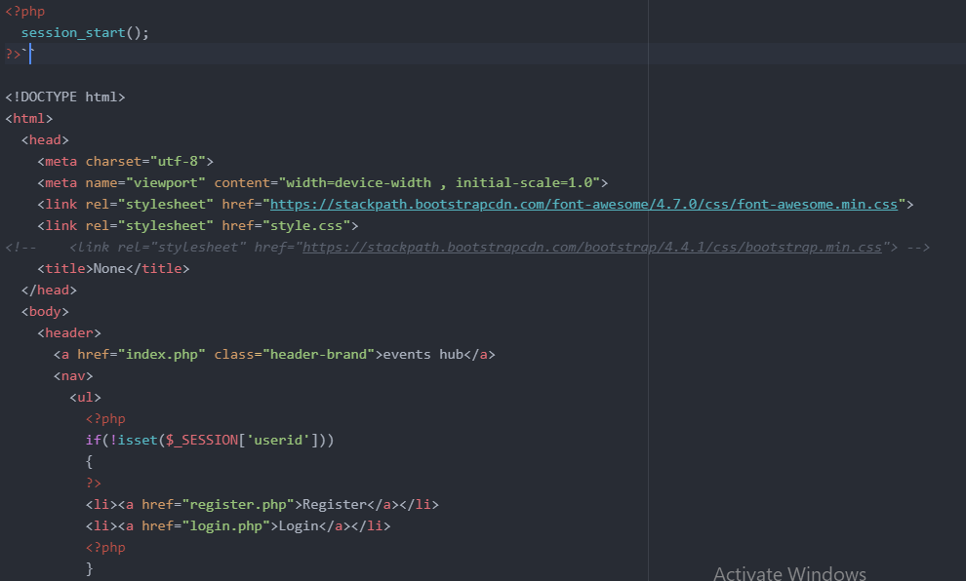

* FOOTER:

This is FOOTER display and code and FOOTER is shown in bottom of every page.

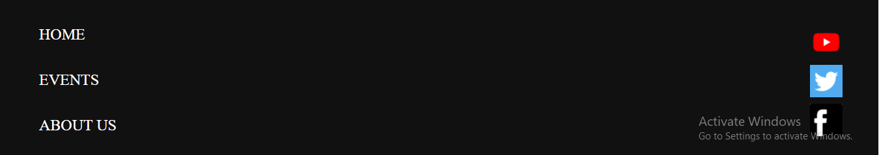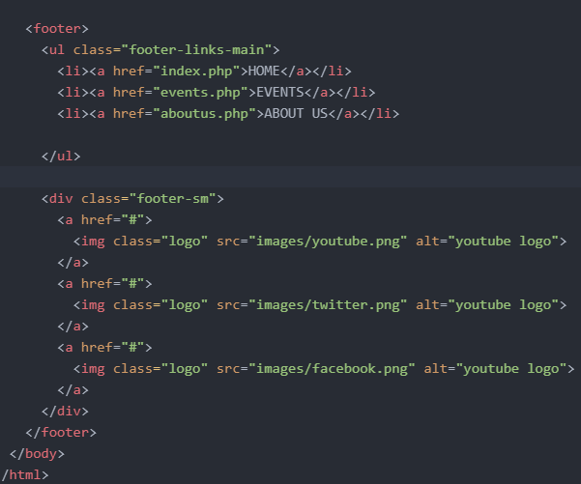

* INDEX PAGE:

Front page (main page) of EVENT HUB. This is the page in which we can access all pages of event hub.

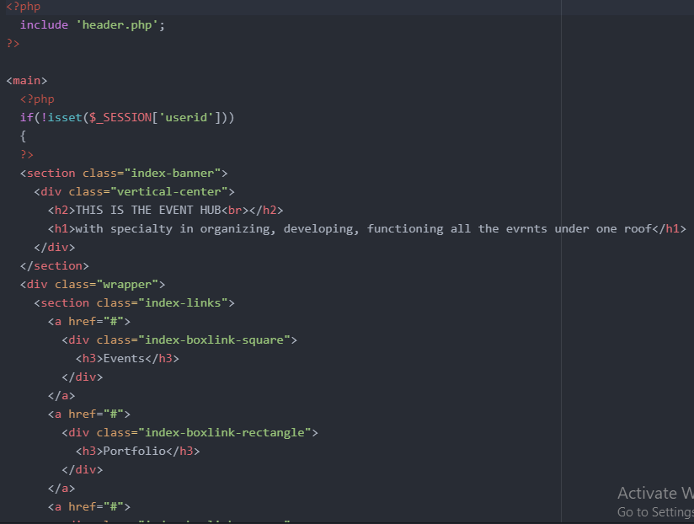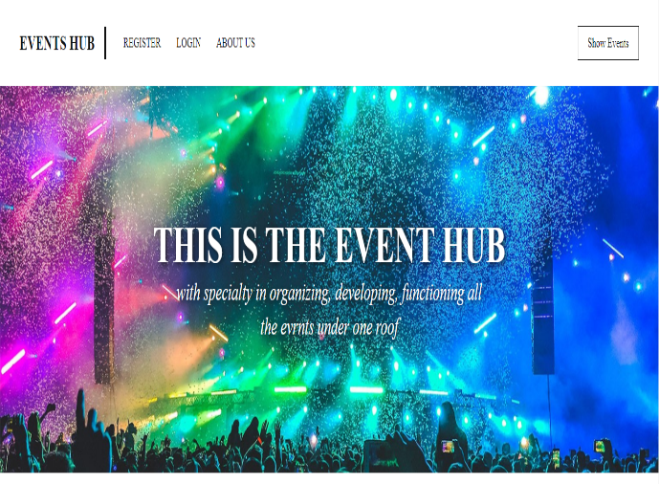

* ABOUT US PAGE:

This page show us the details of owner of this website (event hub).

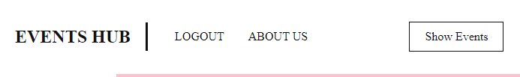

This arrow show us the button of ABOUTUS when we click the button so it will open new page which is shown below.

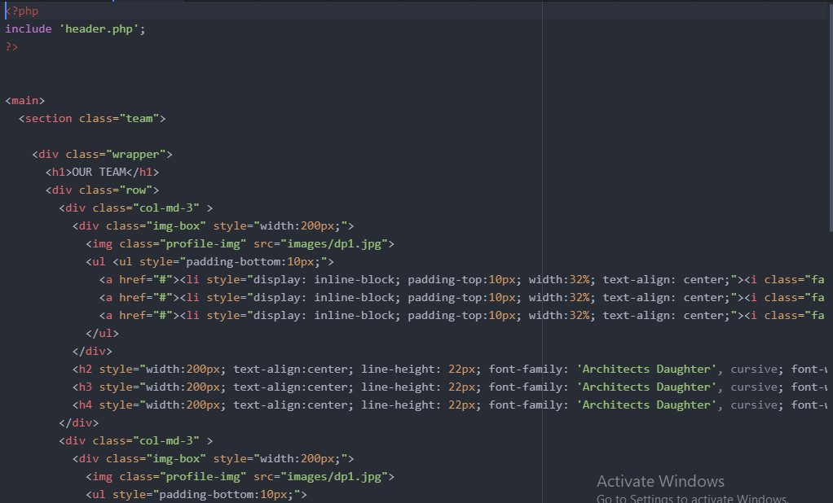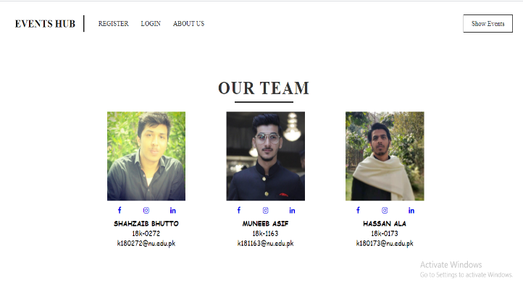

* REGISTER PAGE:

To make REGISTER page we make 3 different files and link each other

1) First we make class of register in which we define attributes call function , check validation and insert query etc.

2) Second we make register.php file in which we make a register from using html/css/php then we call signup.inc.php file to link with database and save data.

3) Last we create signup.inc.php file in which we connect with database and save data into database.

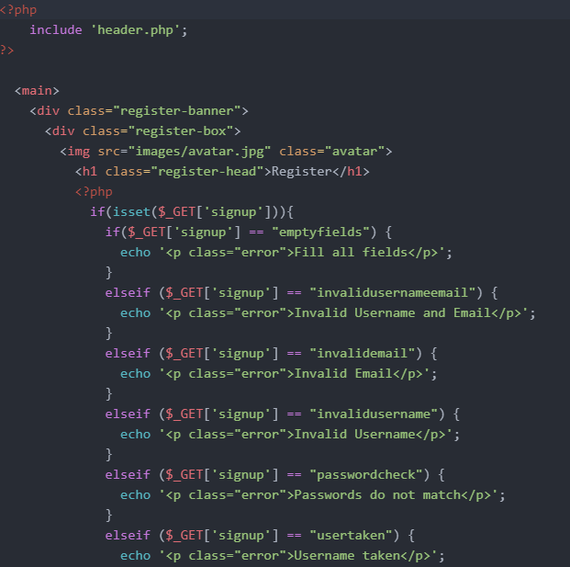 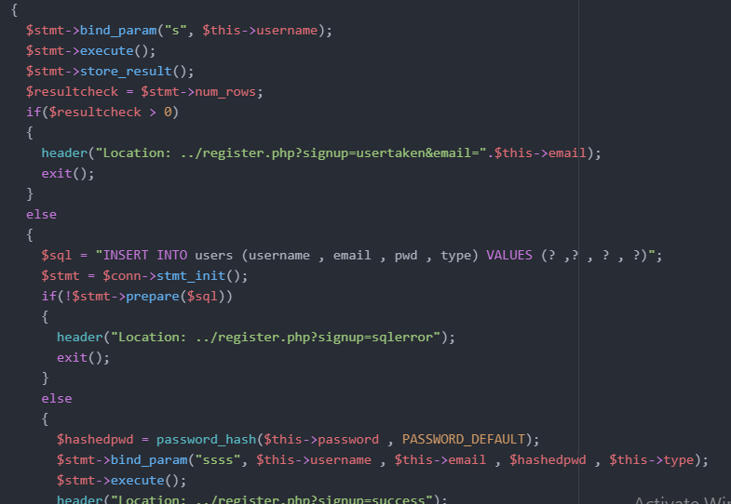

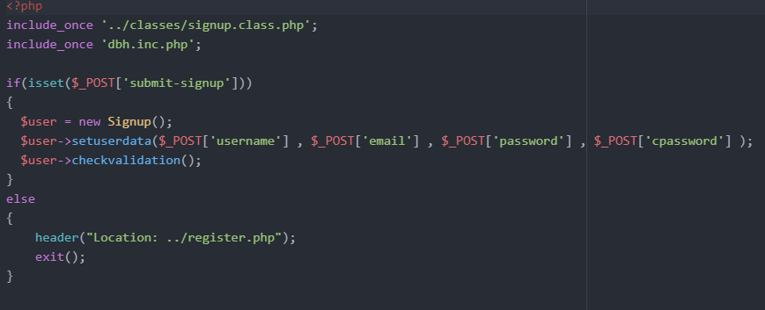

RESULT OF THIS:

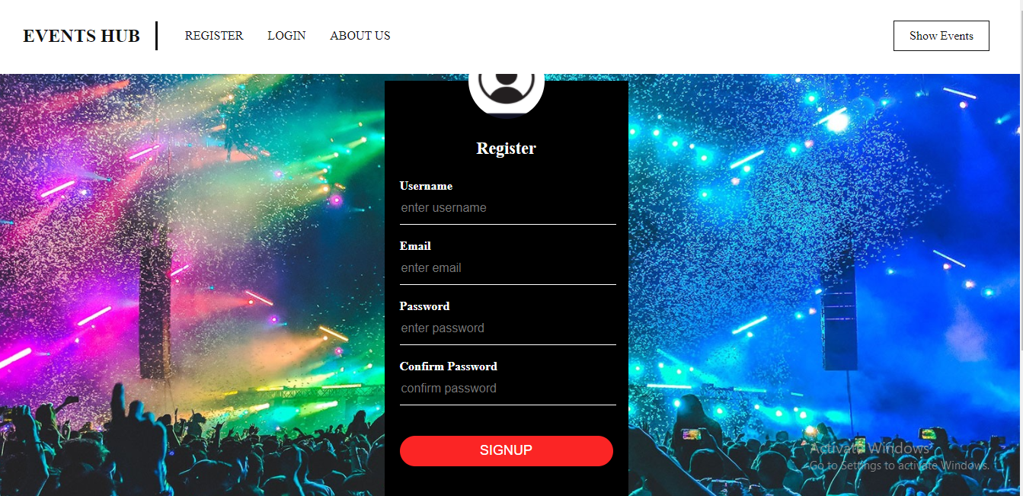

* LOGIN PAGE:

To make LOGIN page we make 3 different files and link each other

1) First we make class of login in which we define attributes call function, check validation and compare query etc.

2) Second we make login.php file in which we make a register from using html/css/php then we call signin.inc.php file to link with database and save data.

3) Last we create signin.inc.php file in which we connect with database and save data into database.

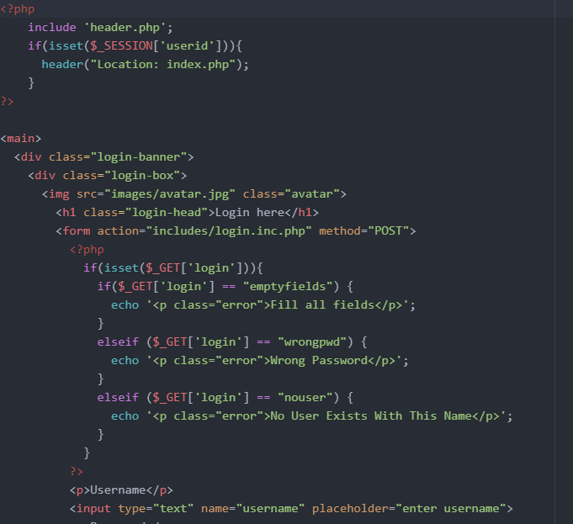 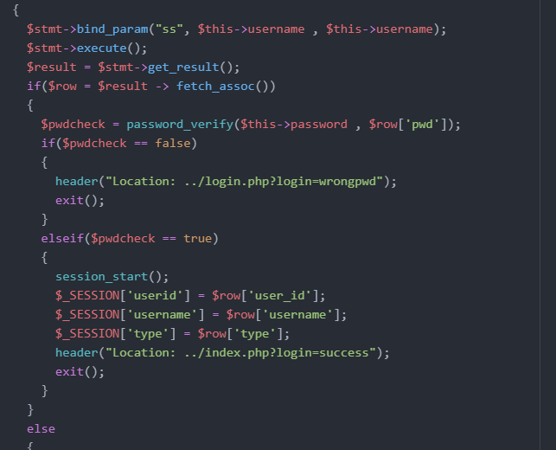

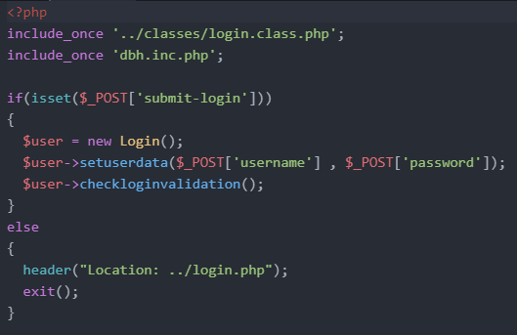

Result of this:

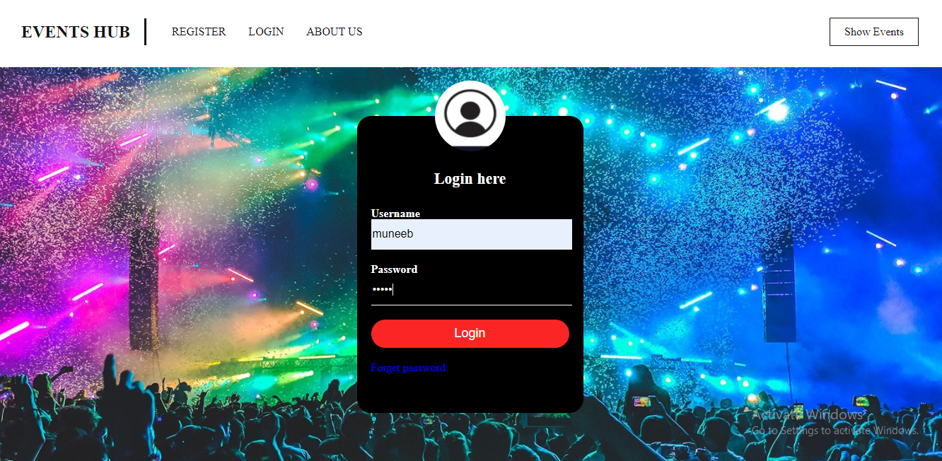

**After click the login button this page appear:**

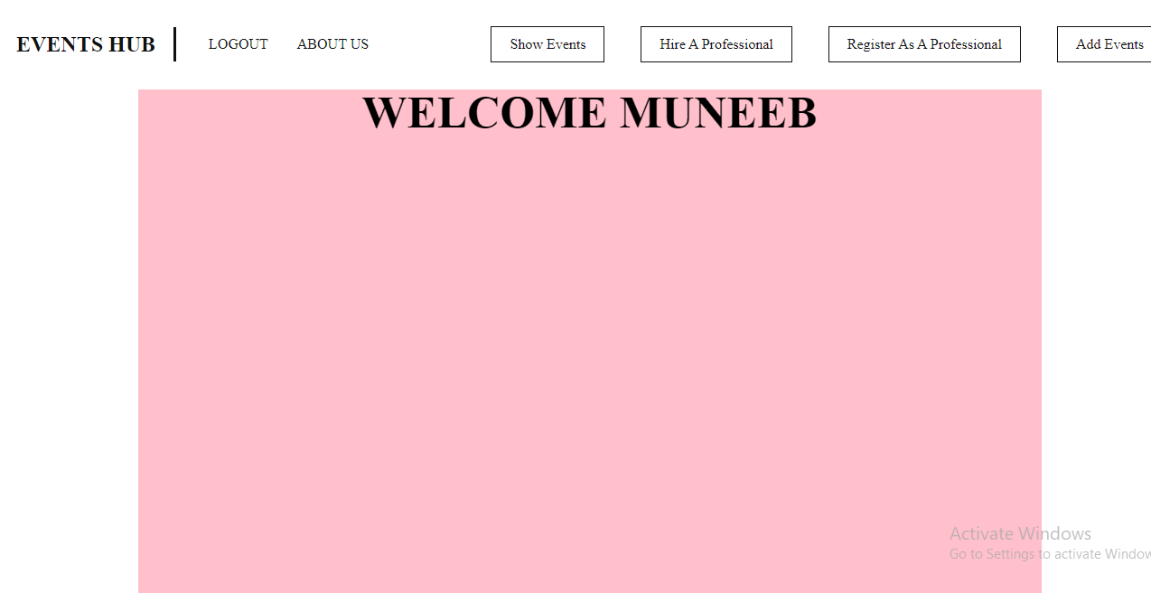

* LOGOUT:



By click the logout button session end and user logout.

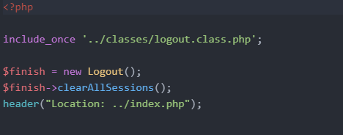

* REGISTER PROFESSIONAL PAGE AND HIRE PROFESSIONAL PAGE:

In this page people who have some skills related to events register themselves so that people who needs that kind of person for their event so they can hire them.

In hire professional page people can see all people who register in this website and give you the detail about person so you can hire them.

If you want to register as a professional to click on this button

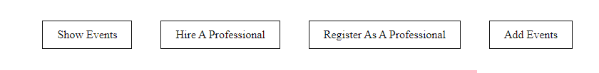

If you want to Hire a professional to click on this button

REGISTER PROFESSIONAL:

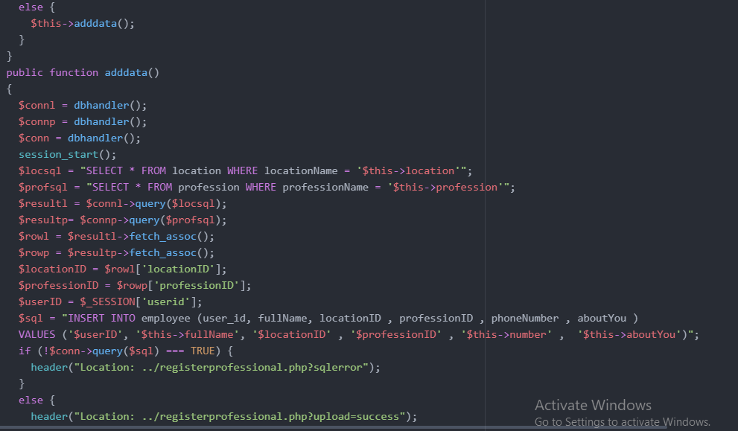 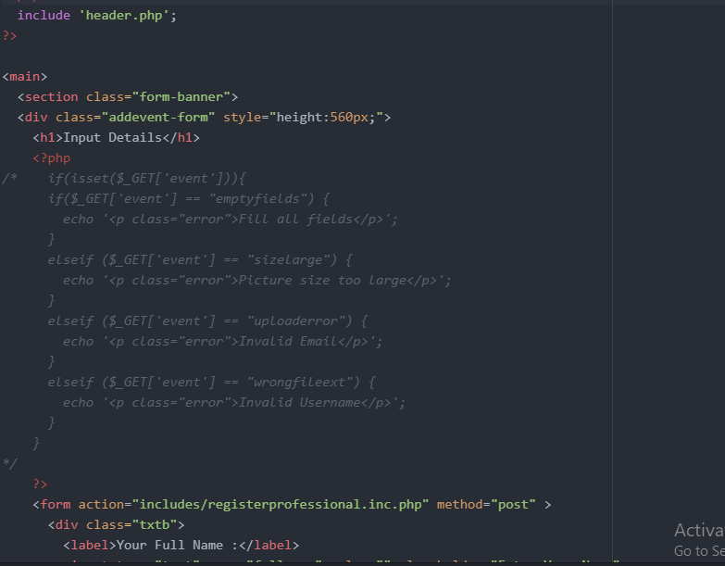

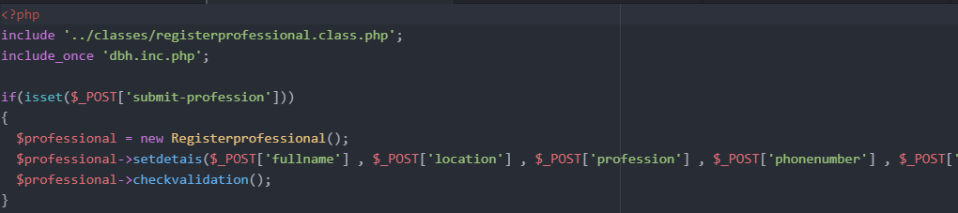

RESULT OF THIS:

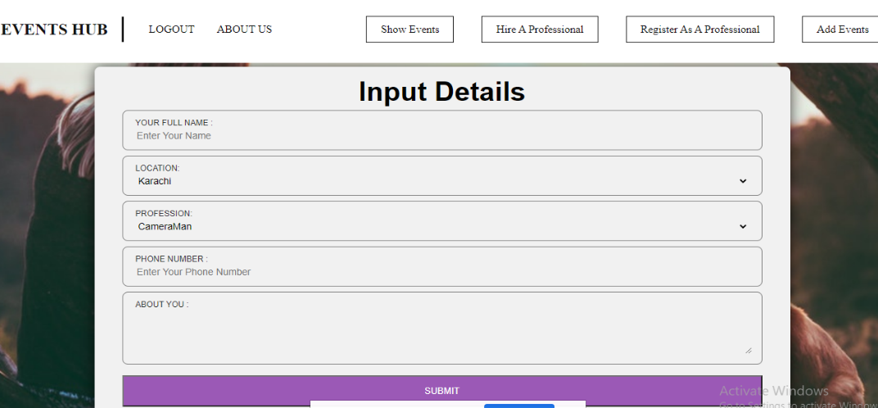

HIRE PROFESSIONAL:

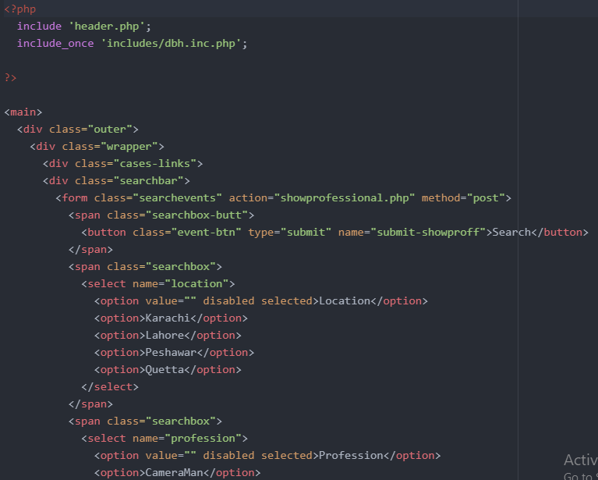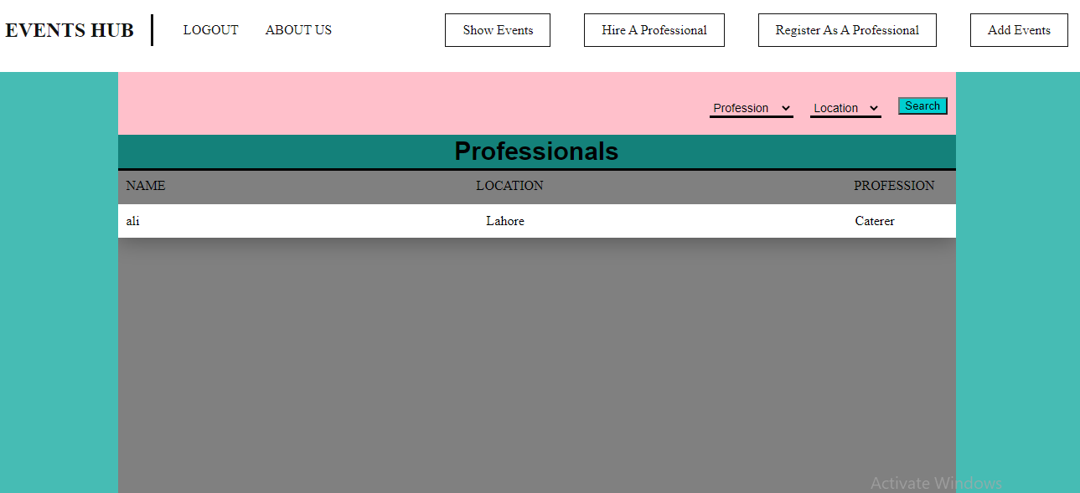

* ADD EVENTS:

In this page those people who already registered when they login their page so they have option to add events if they want and fill all the requirements but when they click the submit button so information goes to admin if admin approve the event so then people see this event else if admin declined so event will be deleted.

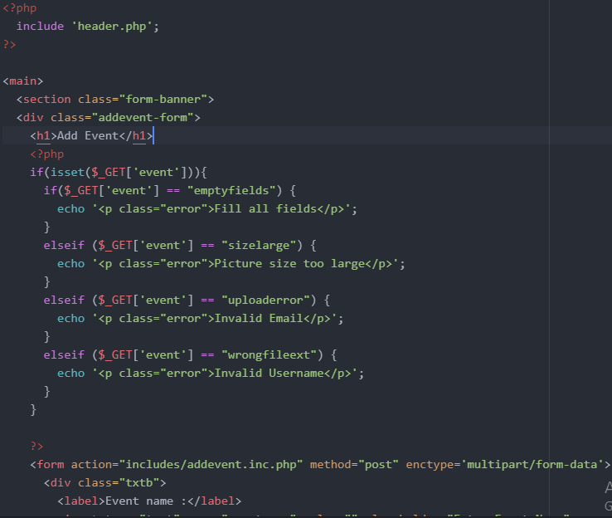 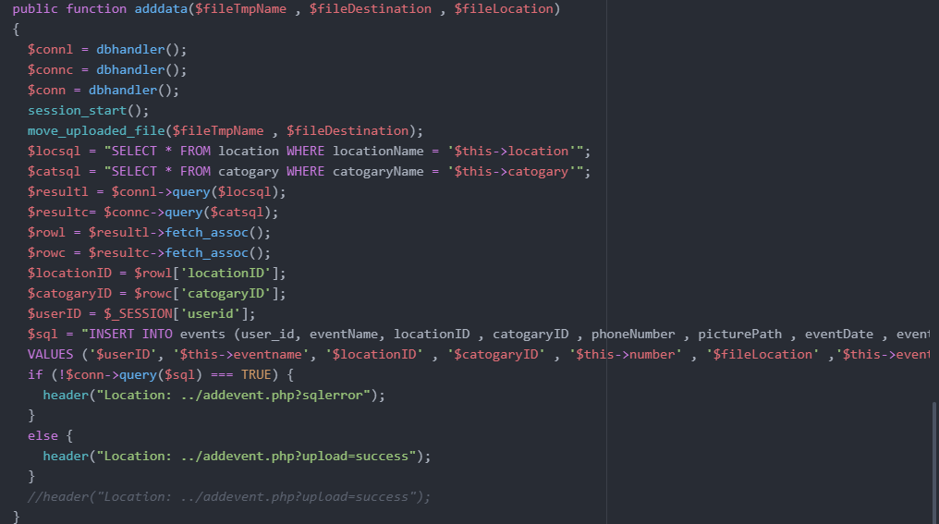

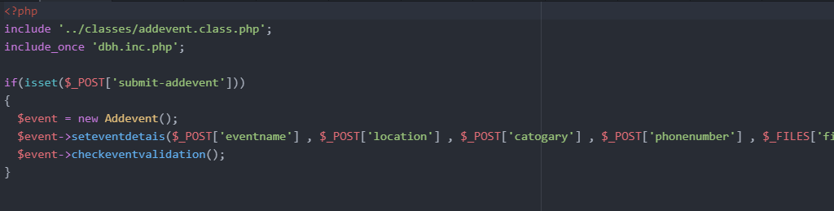

RESULT OF THIS:

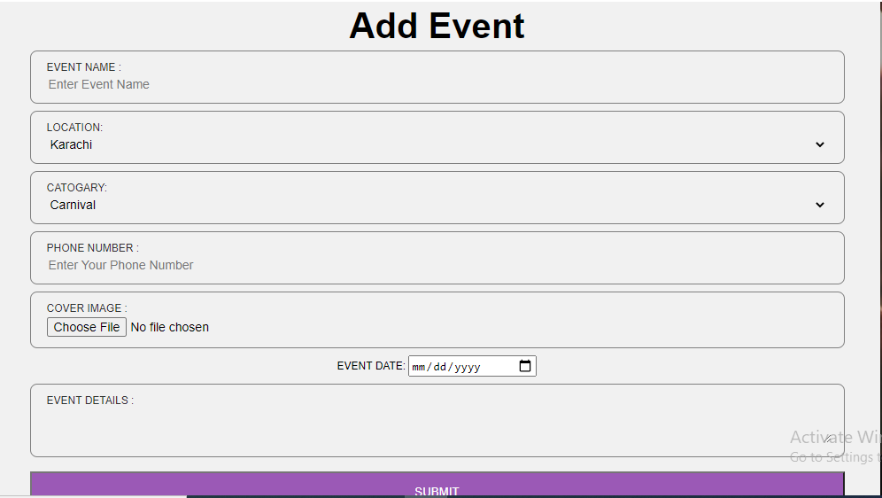

* SHOW EVENTS:

In the page people see those event who approved by admin and then we can also search the event through event date, location, category.

And we not only see list of events but also we see any event specifically by clicking on that event.

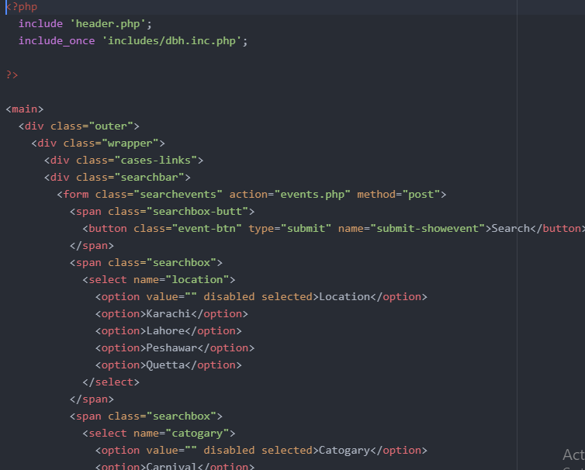 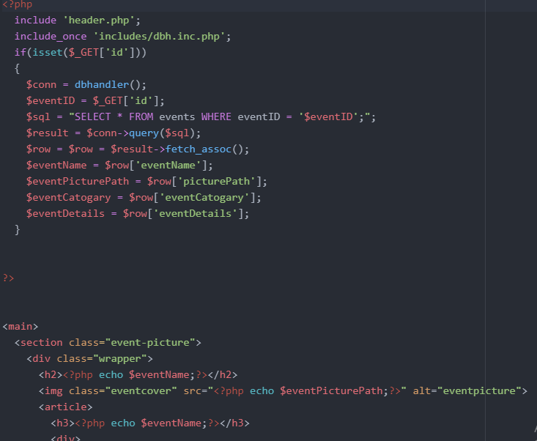

RESULT OF THIS:

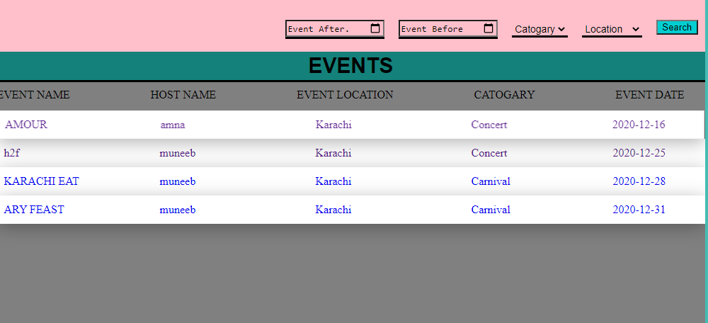

**We can also find more details of any event by clicking it.**

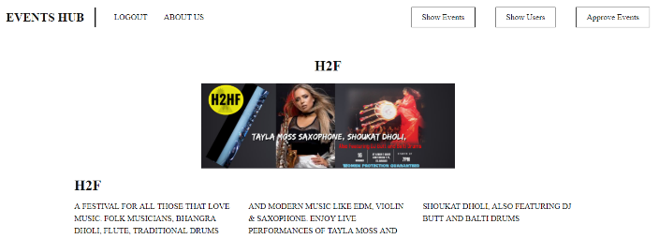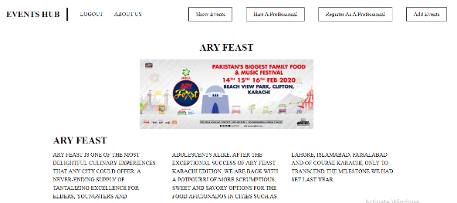

* ADMIN PANEL:

In admin panel we can control whole website. Admin can access each and everything. Admin is the one who approve the event, declined the event and see every details of users.

Admin panel have two option in this website:

1) **SHOWUSER:**

In this page admin can see the count of add event of one user and detail of the user.

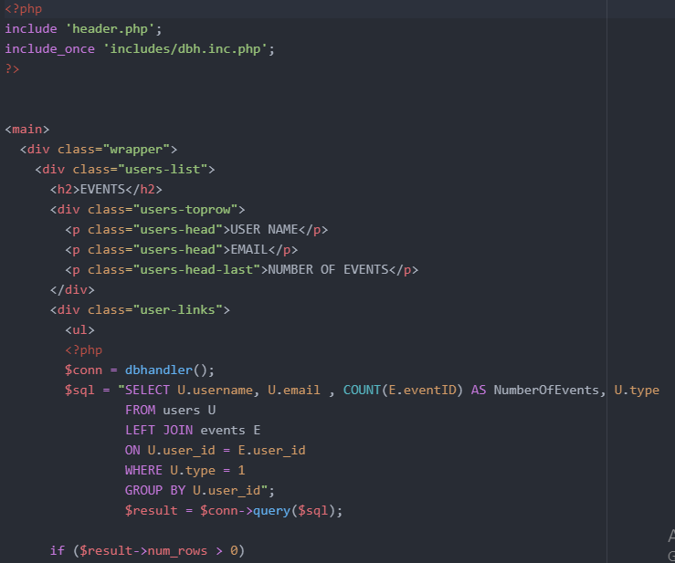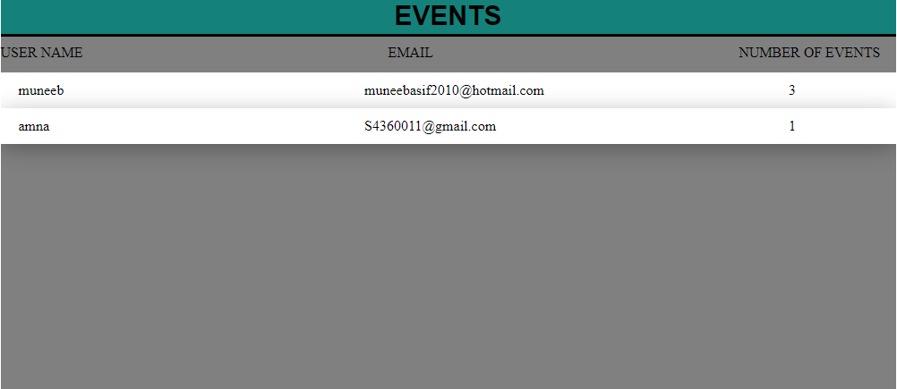

2) **APPROVE/DECLINE EVENT:**

In this page admin have right to approve /decline any event.

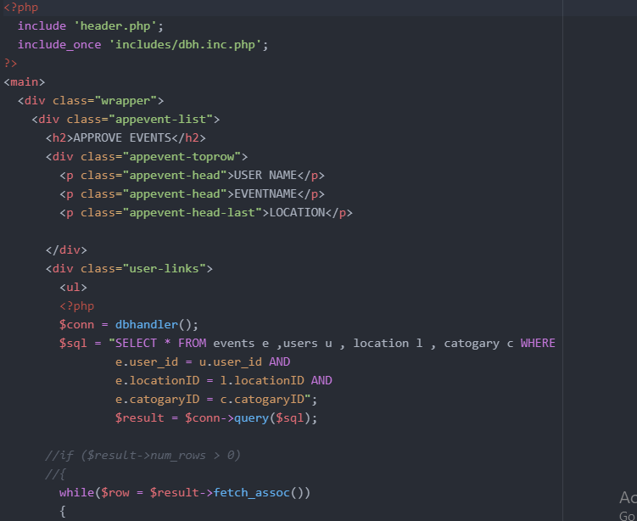

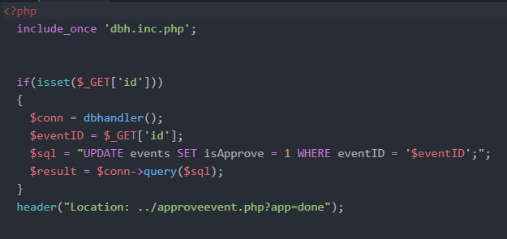 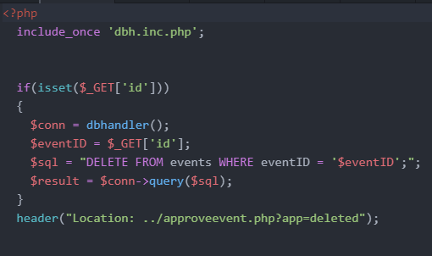

RESULT OF THIS:

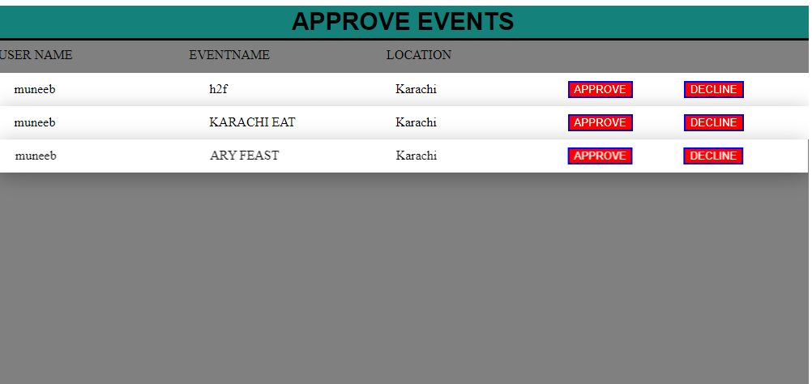

# DATABASE:

* CONNECTION DATABASE:

DB.INC.PHP connect the program with database so we can save the data into phpmyadmin(mysql )and we can also access our data through phpmyadmin(mysql)

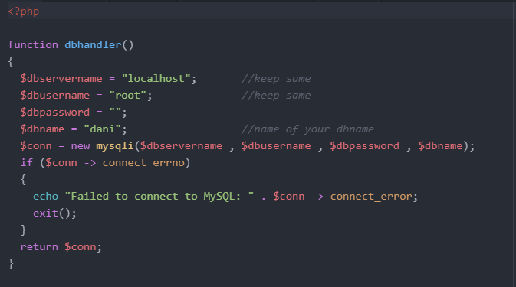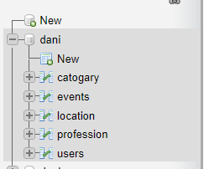

* TABLES:

**TOTAL TABLES:**

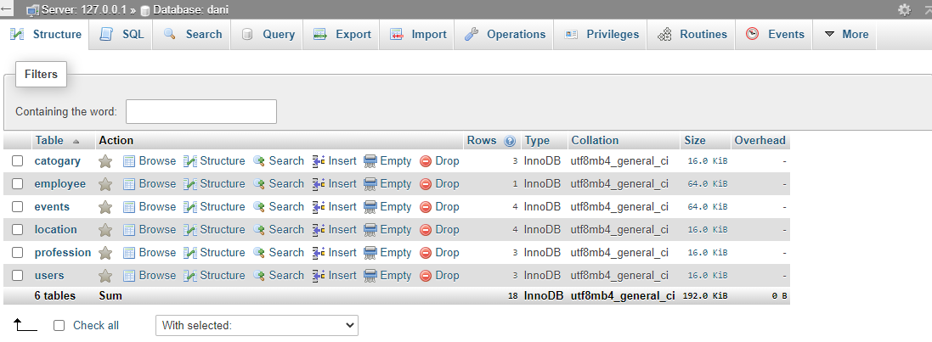

**1: USERS:**

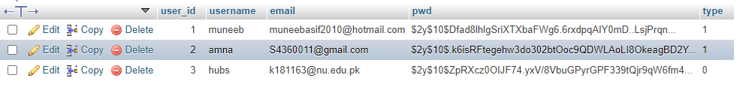

This blue arrow shows us admin id and password (type 0).

Admin type=0 else all type=1

**2: EVENTS:**

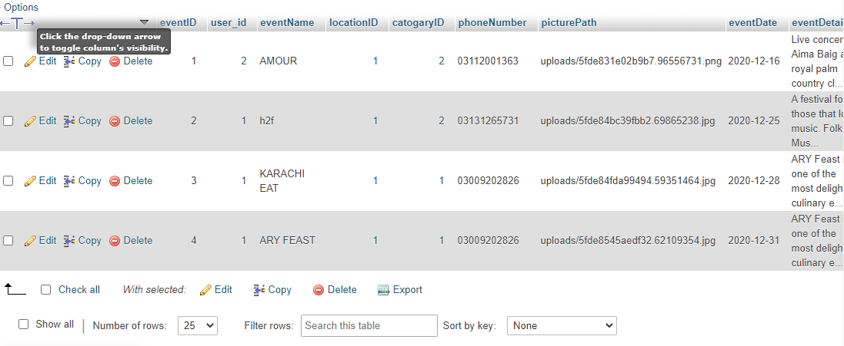

**3: LOCATION:**

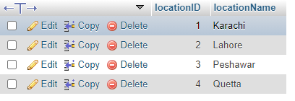

**4:CATEGORY:**

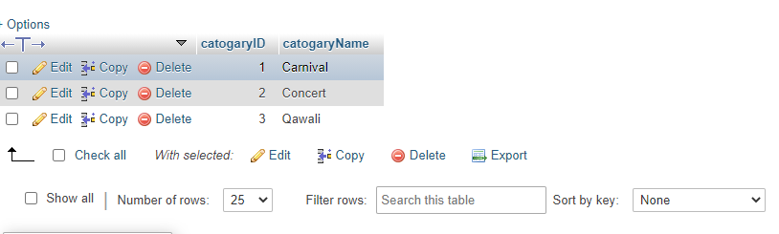

**5:PROFESSIONAL:**

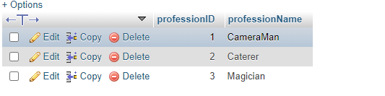

**6:EMPLOYEE:**

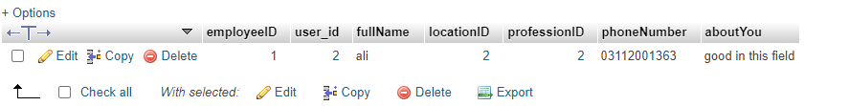

# ERD(Entity Relationship Diagram):

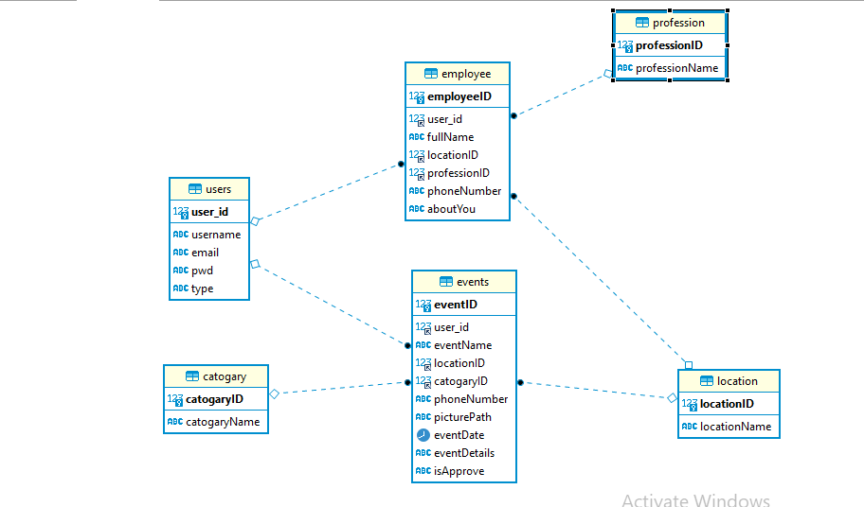

Normalization**:**

**1NF:** (Key is UserID,EmpID,EventID)

|  |  |  |  |  |  |  |  |  |  |  |  |  |  |  |  |  |  |  |  |  |
| --- | --- | --- | --- | --- | --- | --- | --- | --- | --- | --- | --- | --- | --- | --- | --- | --- | --- | --- | --- | --- |
| userID | empID | eventID | username | Email | Pwd | Type | Fullname | LocID | locName | ProfID | Prof_name | Phone | About | eventName | catID | CatName | PrePern | E_Date | E_Details | isApproved |

FD1

FD2

FD3

FD4

**2NF:** (Removing all partial dependency)

|  |  |  |  |  |
| --- | --- | --- | --- | --- |
| userID | username | Email | Pwd | Type |

T1:

T2:

|  |  |  |  |  |  |  |  |  |
| --- | --- | --- | --- | --- | --- | --- | --- | --- |
| empID | UserID | FullName | LocID | LocName | ProfID | ProfName | Phone | About |

Transitive Dependencies

T3:

|  |  |  |  |  |  |  |  |  |  |  |  |
| --- | --- | --- | --- | --- | --- | --- | --- | --- | --- | --- | --- |
| EventID | UserID | LocID | LocName | Phone | EventName | CatID | CatName | PrePern | EventDate | EventDetails | isApproved |

Transitive Dependencies

**3NF:**

|  |  |  |  |  |
| --- | --- | --- | --- | --- |
| userID | username | Email | Pwd | Type |

T1:

T2:

|  |  |  |  |  |  |  |
| --- | --- | --- | --- | --- | --- | --- |
| empID | UserID | FullName | LocID | ProfID | Phone | About |

T3:

|  |  |
| --- | --- |
| ProfID | ProfName |

T4:

|  |  |
| --- | --- |
| LocID | LocName |

T5:

|  |  |  |  |  |  |  |  |  |  |
| --- | --- | --- | --- | --- | --- | --- | --- | --- | --- |
| EventID | UserID | LocID | Phone | EventName | CatID | PrePern | EventDate | EventDetails | isApproved |

T6:

|  |  |
| --- | --- |
| CatID | CatName |

**PROJECT Walkthrough:**

Google drive link:

(https://drive.google.com/file/d/1BmFjtOzT47-yRwfePRu0YBBlRxar0DFV/view?usp=sharing)

# Future Work:

We are working on the booking system for Event Management. For this we are implementing a secure payment method via debit/credit card or cash on delivery (like amazon, fiverr) .The user can hire a specialist for their event such as Event Manager, Camera Man, Lighting expert, etc.

# Conclusion:

In the end this website is used to browse upcoming events all over Pakistan and users can directly add events to the website for all the users to see it. Users can book tickets, hire experts for the events etc.

# Team Members:

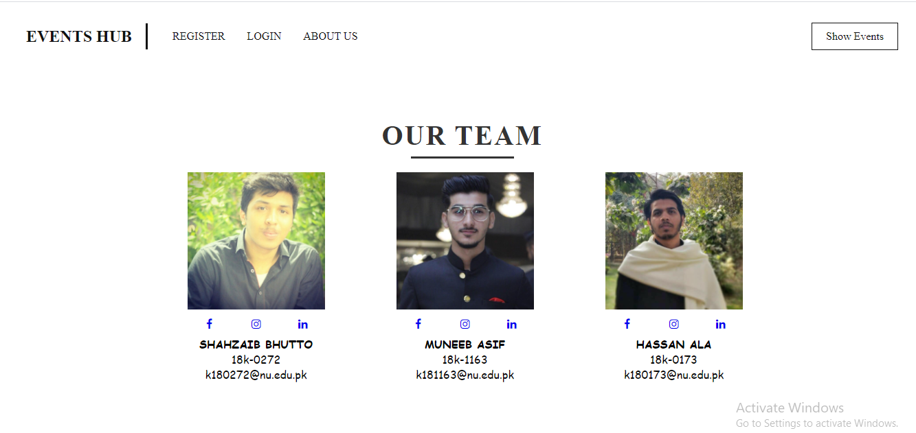

**Section 5-C**

SUPERVISIOR:

**SIR ZULFIQAR ALI MEMON.**

**Status & Remarks (If Any):**